**★★☆☆☆**

**題組：基礎48題**

**題號：Q12908 : The book thief**

**整理者：陳紫淇**

**學號：ADT105142**

**使用語言:C++**

**解題日期：2018年8月3日**



**題目:**

On February 18, 2014, Red Matemtica proposed the following mathematical challenge on their twitter account (@redmatematicant): “While Anita read: The book thief by Markus Zusak, She added all the page numbers starting from 1. When she finished the book, she got a sum equal to 9.000 but she realized that one page number was forgotten in the process. What is such number? and, how many pages does the book have?”

Using this interesting puzzle as our starting point, the problem you are asked to solve now is: Given a positive integer s (1 ≤ s ≤ ${10}^{8}$) representing the result obtained by Anita, find out the number of the forgotten page and the total number of pages in the book.

**Input**

The input may contain several test cases. Each test case is presented on a single line, and contains one positive integer s. The input ends with a test case in which s is zero, and this case must not be processed.

**Output**

For each test case, your program must print two positive integers denoting the number of the forgotten page and the total number pages in the book. Each valid test case must generate just one output line.

**Sample Input**

1

2

3

4

5

6

9000

499977

49999775

0

**Sample Output**

2 2

1 2

3 3

2 3

1 3

4 4

45 134

523 1000

5225 10000

**問題描述：**

老師就讀國小的兒子正在學加法，他喜歡把書本翻開，從第1頁開始一頁一頁翻，然後把這些頁數加起來。例如有一本書有10頁，他就會做1+2+3+4+5+6+7+8+9+10。這結果是55。

有一次他又拿一本書在那邊做加法練習，可是在加的過程中他漏掉了某一頁沒加到。他跑來找我請我幫他算出到底是哪一頁沒加到，但是他只告訴我他加起來的結果，他甚至沒告訴我這本書有幾頁。

請你寫一個程式幫老師算出他漏掉的是哪一頁以及這本書總共有幾頁。

輸入說明：

輸入含有多筆測資。

每筆測資一列，含有一個正整數 s （1 <= s <= 108），代表我兒子告訴我他加起來的結果。當s=0時代表輸入結束。

輸出說明：

每組測資輸出一列，輸出我兒子漏掉的是哪一頁以及這本書總共有幾頁。

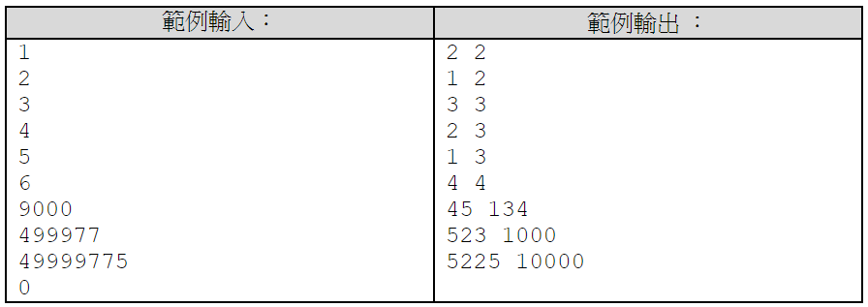

**解法:**

令這本書總共有n頁

第i頁為漏掉的那頁

題目的輸入為x(已知)

所以x = (n+1)n/2 – i

2x = $n^{2}$ +n-2i

由於 1 <= i <= n (第1頁到最後一頁都有可能是i)

得知n-2i 的範圍落在 –n~n-2 之間

所以我們將2x開根號，得出可能的n ，再計算n-2i是否落在–n~n-2 之間

舉例

2=1+plus

2=4+-2

|  |  |  |  |  |  |
| --- | --- | --- | --- | --- | --- |
| x (input) | $$\sqrt{2x}$$ | n | n-2i.  plus | plus range | 在範圍內 |
| 4 | 2.82 | 2 | 4 | -2~2 | No |
| 3 | -1 | -3~1 | yes |
| 5 | 3.16 | 3 | 1 | -3~1 | yes |
| 4 | -6 | -4~2 | No |
| 1 | 1.41 | 1 | 1 | -1~-1 | no |
| 2 | -2 | -2~0 | yes |

如此我們就能知道總共有3頁，漏掉的是第2頁

**解法範例：**

1. 定義find函式將2x開根號，先無條件捨去作為n
2. 計算n-2i (程式中命名為plus)是否在 –n~n-2之間，在範圍內就是正確的n
3. 若n-2i不在正確範圍，將n+1就是正確的n
4. 找到正確的n就能算出i

#include <iostream>

#include <math.h>

using namespace std;

void find(long x)

{

long n = long( sqrt(2*x) );

long plus = (2*x)-(n*n);

long i;

if( (plus>=(-1*n)) && (plus<=(n-2)) )

{

i = (n-plus)/2;

printf("%d %d\n",i,n);

}

else

{

n=n+1;

plus = (2*x)-(n*n);

i = (n-plus)/2;

printf("%d %d\n",i,n);

}

}

int main()

{

long x ;

while(cin>>x)

{

if(x!=0)

find(x);

else

break;

}

}